13. Dig the Data
Sort It Out: Filter versus Sort with Excel Part 3

You just completed an activity using a spreadsheet tool for sorting a database of songs. You organized the data by categories (sorted the list by Artist, Title and Genre).

- 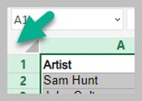 Selected all the data
- 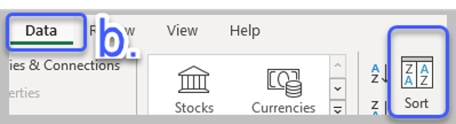 Data menu
- 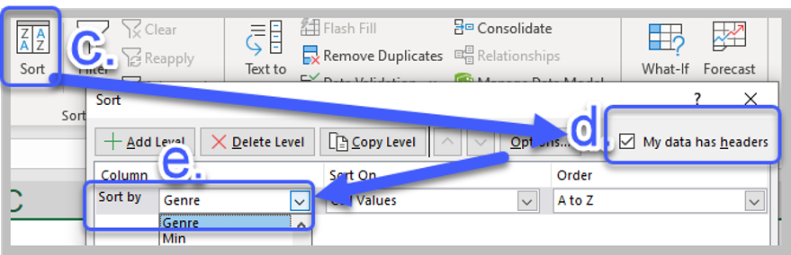 Sort by…

Another tool that is helpful for organizing data is called filtering. Filtering data helps you focus in on specific data and hide unimportant data. Try it out with the following STEPS.
STEPS
- Data Menu 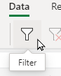
- Click on Filter
- Select the column you want to filter and click on the drop-down that appears at the top of
the column.
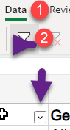

- To see a list of songs in ONLY two genre choices.
- Select ALL (to uncheck all of them).
- Use the filter drop-down in the Genre column.
- Check only two genre choices on the list (your choice).
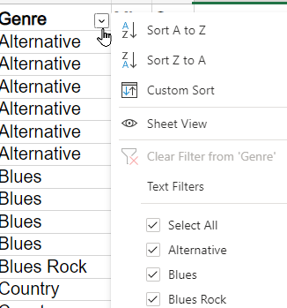 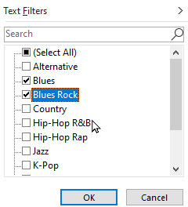
- Result of selecting Blues and Blues Rock. Notice that ALL the other songs are Filtered out of view.
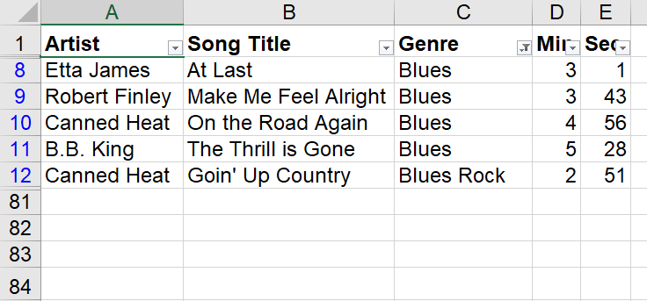
(use undo or Ctrl-Shift-L to remove the filter and see all the songs again)
Question: How is this different than doing a Sort?
- Filtering by numerical value. This is even better.
  - Turn on filters again (remember how? Steps 1-3)
  - Use the filter drop-down for Column D 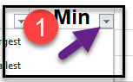
  - Select Number Filters (2)
Select Less Than Or Equal To…(3)
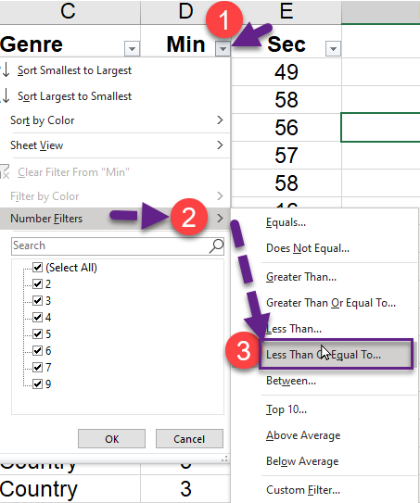 The Custom AutoFilter box opens.
  - Type the number 3 in the box and select OK.
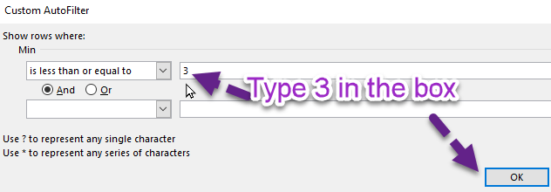
Challenge 1: Can you filter by your 3 favorite artists?
Challenge 2: Would you use Sort or Filter to organize your Playlist songs from shortest to longest song?
Challenge 3: Is there a family member that uses spreadsheets where you could teach them how to Sort and then Filter their spreadsheet data?

Congratulations for learning more skills with Spreadsheets!

